16.56: a) The cross-section area of the string would be corresponding to a radius of 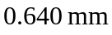(keeping extra figures). The length is the volume divided by the area,

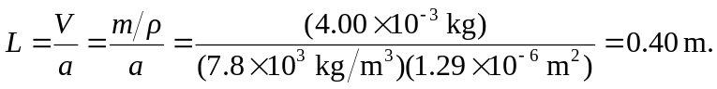

b) Using the above result in Eq. (16.35) gives 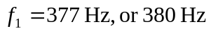to two figures.

